Employee BIG 3 Goals Process

All forms used for creating your BIG 3 can be downloaded from the Leadership Resources page (<https://gr8resultssystem.com/leadership-resources/>). Use **ONLY one** *BIG 3 Planning Form* for each goal. The following is what you will do for each BIG 3 Goal. The BIG 3 Goals Preparation Form, BIG 3 Planning Form, and SMART form are included in this document.

# Goals Preparation

Your answers to the questions will help you create your high-performance goals and values. Download the form or copy and paste the questions to your device to answer. The best answers are based on reality, not feelings.

1. Review company, unit, and team goals. In your role, what goals can you set for yourself to help your team meet their goals?
2. Are you being fully utilized?
3. Do you have any suggestions, best practices, or innovations to accelerate or enhance business activities and processes?
4. What part of your work is interesting and challenging?
5. Describe what is not interesting or challenging.
6. What part of your work gives you the most difficulty and why?
7. How do these difficulties impact your unit, team, or group?
8. How can your supervisor help you meet your objectives?
9. How could your supervisor contribute to your success?
10. What could they do differently?
11. What do you want more of from them? Less of from them?
12. Do you have any suggestions to improve your productivity and effectiveness?
13. What ideas do you have for improving how we get things done more efficiently?
14. In what areas can we reduce costs in your immediate unit, team, or group?
15. How can you promote knowledge sharing and understanding of our competitors?
16. How can you enhance environment, health, and safety performance?
17. What can you do during this next year to further promote the company’s core values?

# BIG 3 Planning Form

## A blank form with text AI-generated content may be incorrect.THERE Section

**Step 1** – If you do not have ideas for goals, answer the *BIG 3 Goals Preparation Form* questions. Your answers can give you ideas for the three goals you want to achieve in the next three to twelve months. If you already have three goals, move on to Step 2.

**Step 2** – Download a *THP BIG 3 Planning Form*. If you prefer to write, download the PDF; otherwise, use the MS Word file.

**Step 3** – Put your idea for a goal into the “My THERE Idea” at the top of the form.

**Step 4** – Review the SMART Goals document to refresh your mind about each item.

**Step 5** – Use the *SMART Goals* document information to create a THERE that meets all SMART criteria. The “R – Result-oriented” is a challenge for most people. Your goal is an “end result”; therefore, it does not include any actions in the description. Generally, words like “by” or “through” add actions to the goal statement.

Write your SMART THERE in that space on the form. Check the blank at the end of each SMART criteria if it is reflected in your THERE.

**Step 6** – Enter the Due Date at the top right of the form.

**Step 7** – Enter the key metric in the “THERE Key Metric” in the box on the right side of the THERE section.

**Step 8** – Answer the Purpose and Core Values questions.

## HERE Section

The best way to complete the HERE section is through objectivity and honesty. Create an objective report about where you are in relation to the goal (THERE) you want to achieve. The clarity of the HERE helps you identify the next actions to take.

Use two categories of current reality: 1) what you KNOW, the facts, not your opinion, and 2) what you DO NOT KNOW (DNK). Both are related to the THERE, and are extremely important for developing your actions. If you write an estimate or speculation, write DNK at the beginning of the statement. Finally, only one item for each bullet in the HERE section.

**Step 9** – Write the level of the metric of where you are now in the “HERE for Key Metric” box on the right side of the HERE section. For example, if your THERE is the desired size of your waist or how much you want to weigh, then state your current waist size or weight.

**Step 10** – Write as many other facts that you know and do not know (DNK) in relation to the THERE. Remember, only one item for each bullet point.

## PATH Section

**Step 11** – Use the facts in the HERE section for your beginning actions. For each HERE item, ask, “Does this imply an action is needed?” Many times, there are multiple actions from individual HERE items. List as many actions as you want.

**Step 12** – For each action, list a Due Date. If you want to make it more robust, determine a Progress Measure and list others who will work on the action with you. You are responsible for all PATH items listed, but others can help you complete the action or task.

**Step 13** – Keep your PATH items small because that will help you get started. If you want to create a more robust list, do not let your planning keep you from doing the actions listed.

**Step 14** – Write the date you prepared this form.

**Step 15** – Review the form with your supervisor. Make changes as needed. Have them sign the form.

**Step 16** – Ask them how they prefer to check on your progress. Your BIG 3 Goals may need to be listed on the team’s goals and tasks list.

Big 3 Planning Form

|  |  |  |  |  |
| --- | --- | --- | --- | --- |
| **1. THERE—Goal, Desired Outcome Due Date** | | | / / | |
| **My THERE idea**: | | | | |
| **My SMART THERE:** Specific___ Measurable___ Acceptable___ Result-oriented (not actions)___ Time-(Due Date)__ | | | **THERE Key Metric** | |
| **Does it support our PURPOSE?** Yes No **Does it support our Core Values?** Yes No | | | | |
| **2. HERE—Current Reality (**Objective report about where you are now concerning the above SMART THERE, **1 item/bullet**) | | | **HERE for Key Metric** | |
|  |  | | | |
|  |  | | | |
|  |  | | | |
|  |  | | | |
|  |  | | | |
|  |  | | | |
|  |  | | | |
|  |  | | | |
|  |  | | | |
| **3. PATH—Actions** (For each HERE item, ask, “Does this imply an action is needed?” Write 1 action/row.) | **Progress Measure** | **Partners** | | **Date** |
|  |  |  | |  |
|  |  |  | |  |
|  |  |  | |  |
|  |  |  | |  |
|  |  |  | |  |
| ***More rows on the back. After listing actions, put them into the Excel workbook (GoalsTasks.xlsx) or your task tracking app.*** | | | | |
| Date Prepared: | **Approved by:** | | | |

|  |  |  |  |
| --- | --- | --- | --- |
| **3. PATH—ADDITIONAL Actions** | **Progress Measures** | **Partners** | **Date** |
|  |  |  |  |
|  |  |  |  |
|  |  |  |  |
|  |  |  |  |
|  |  |  |  |
|  |  |  |  |
|  |  |  |  |
|  |  |  |  |
|  |  |  |  |
|  |  |  |  |
|  |  |  |  |
|  |  |  |  |
|  |  |  |  |
|  |  |  |  |
|  |  |  |  |
|  |  |  |  |
|  |  |  |  |
|  |  |  |  |
|  |  |  |  |
|  |  |  |  |

S.M.A.R.T. Goals

# S—SPECIFIC: The Details Make the Difference

* A list of tasks with text

  AI-generated content may be incorrect.Clear, specific, and picturable
* Exactly what you want in concrete terms
* You will know your goal is specific if:
  + Everyone involved knows the specifics of their involvement
  + Everyone involved understands and is clear about the desired end result
  + Your objective is free from jargon
  + You have defined all terms
  + You have used only appropriate language
* These **are not** clear goals
  + Increase production and reduce costs
  + Improve report writing skills
  + Increase petrophysical knowledge by year-end by increasing comfort in log reviews
  + Greater communication with direct reports by the end of Q2
  + Create a more positive work environment
  + Regularly follow up with team members and direct reports
* These are **well-stated goals**
  + Increase production: Drill 4 wells, adding 10 Bcf at a $0.50/Mcf F&D cost by Q4
  + Reduce technical report preparation time by 30% by the end of Q4 and maintain “excellent” feedback rating from peer review team
  + Achieve an “excellent” rating by peer review team on log reviews (specifically, I want…) by Q4 end

# M—MEASURABLE: The Critical Element

* You will know you have achieved your goal because the metric is the evidence. Others can know too! It becomes your statement of success.
* Goals must have some method of tracking progress, measuring success over time
* Metrics are used to define your goal (THERE) and your current reality (HERE)
  + How would you measure weight loss if you did not know how much you weighed?
  + How do you measure employee retention if you do not know the current turnover?
  + Establish baselines (current reality) and measure progress from that point
* Goals are not masters, they are servants supporting personal/company purpose and values
* Define the deliverables, documents, products, and accomplishments desired. Deliverables like documents or Standard Operating Procedures can be your metric.

# A—ACCEPTABLE: Accept the Responsibility

* If you know you can measure it, you can more easily determine whether it is something you are willing to tackle, to put effort into
* Will you accept the responsibility of reaching this goal?
* Is this goal within the scope of your responsibilities?
* Limit the scope to your roles and responsibilities
  + Define the scope to be within your control and influence
  + Your goal is something you can make or help make happen
* You do not have to know whether it is achievable or attainable, that will be tested in the HERE
  + Do you want it even if you do not know if you can achieve it?
  + Are you willing to be accountable for this, knowing there is no guarantee of getting there?
  + Will you agree to put your effort into achieving, even though you are not guaranteed to reach it?

# R—RESULT-ORIENTED (Relevant): It Is NOT About Actions

**Sample Verbs to Use**

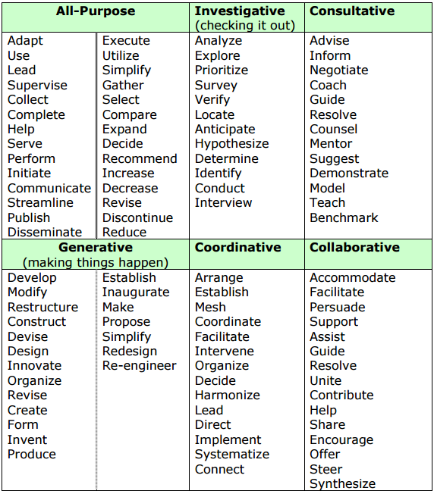

* Make your goals something to achieve. It is not an action and does not include “by” or “through” or other words that say how you want to achieve the goal. The table provides words that are result-oriented to help you.
* Additionally, it may not be relevant even if it meets other criteria. This is where alignment with purpose and strategy is assessed. A key reason it can be irrelevant is that it is not a high priority. Often, something else needs to be done first. If so, set up other goals in priority order.
* Questions:
  + Is this in line with overall organizational activities?
  + Will this contribute to the goals of the organization?
  + Is there a higher priority goal to focus on now?
  + Will this add to, or even multiply, as opposed to subtract from or divide, organizational efforts?

# T—TIME-BOUND: Identify a Clear Due Date

* You must include a due date. Otherwise, your goal is substantially less measurable.
* Without the target date, the measurement of the goal is incomplete
* Deadlines are not set to manipulate you or give you an inordinate amount of time. Set due dates based on when the project is needed or wanted.